ARTIST STATEMENT
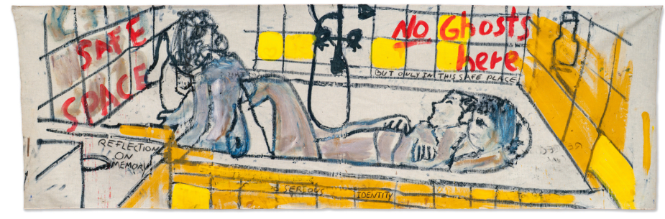

My practice is a process of emotional excavation. I am a digger. I enter a theme or a material with total intensity and stay with it until it resists me, until it refuses further manipulation. Only then do I surface and begin again. My practice functions as a ritual of ontological fixation; a deliberate attempt to reach the Kern, the irreducible core of a moment, a state, or a self, and crystallize it into form.  I don’t want to hold to a particular narrative; I only enjoy the process of diving. Heavy oils, burned plastic on metal, found wood, mirrors, cloth-materials are chosen for their capacity to endure confrontation. The surface must survive pressure, abrasion, insistence. There is a necessary aggression in this collision a controlled violence required to break through the surface and reach the core.  What interests me is the endurance of a sudden idea while the material continues to respond in a way that is aesthetically attractive to me.  I work primarily on a large scale in order to bypass control. Scale forces the body to participate. In that state, the painting stops being obedient and begins to assert itself. It pushes back. It dictates its own evolution. | 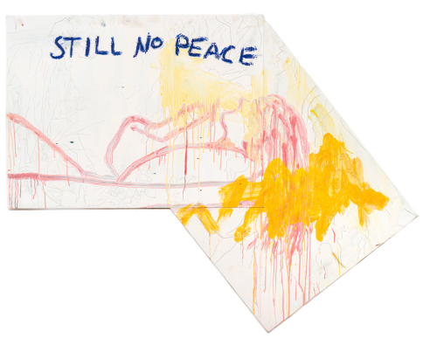
I have zero loyalty to any fixed language. For me, it is more crucial to remain in a permanent state of search than to claim something fixed. The work is not a conclusion. It is evidence of that refusal.

